Milestone 2 - Stakeholders and scenario-based elements

Stakeholders:

1. Developing team

All programmers through the whole phrases.

1. Administrators

End-users who can view and manage part of normal users' information.

Note: no formal investors since we are doing this for free.

Use case diagram:

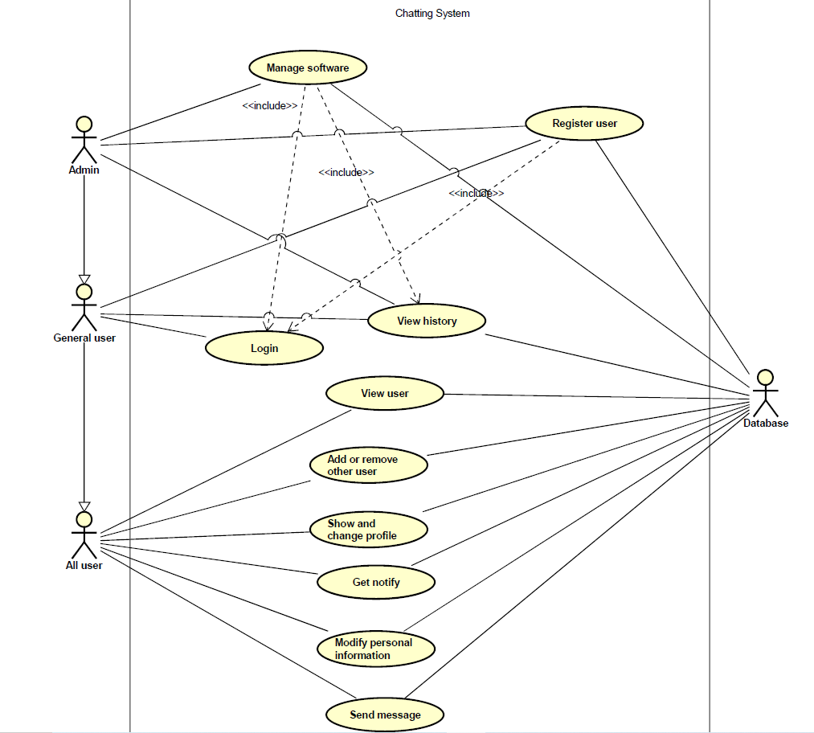

Use case table:

**Register an Account**

|  |  |
| --- | --- |
| Actors | General users, admin |
| Goal | Add a new user to the system |
| Preconditions | Users is not in the system |
| Scenarios | Create a new user  Set permissions depends on normal users or admin |
| Exceptions | Username/ID already exists in the system |

**Users Login**

|  |  |
| --- | --- |
| Actors | General users |
| Goal | Login to the software |
| Preconditions | User is in the system |
| Scenarios | Sign in and password GUI is launched  Success login and fail login notification is launched |
| Exceptions | Username and password are not matched |

**Software management**

|  |  |
| --- | --- |
| Actors | Admins |
| Goal | Manage the software and data |
| Preconditions | Admin logged into the system  Admin has permissions |
| Scenarios | Manage the software  View and manage other users’ accounts |
| Exceptions | No users |

**Password Change**

|  |  |
| --- | --- |
| Actors | General users, admin |
| Goal | Replace old password with a new one |
| Preconditions | Users log in to the system  Old password matches |
| Scenarios | Passwords need to be replaced |
| Exception | Old and new passwords are same |

**View General Chat History**

|  |  |
| --- | --- |
| Actors | General users, admins |
| Goal | View chatting history with friends and contactors |
| Preconditions | Users logged in the system  Talk or chat with who is or was in friends and contactors lists |
| Scenarios | Chat history need to be viewed |
| Exceptions | Local chat file is deleted  Chat history is cleared. |

**Show List of Friends**

|  |  |
| --- | --- |
| Actor: | All User |
| Goal: | To see friends that user added |
| Preconditions: | User must add friend first  User is in the system |
| Scenarios: | Add friend or agree friend application from others  check the friend user add is in the list |
| Exceptions: | user doesn’t add any friend |

**Show User’s ID and Profile**

|  |  |
| --- | --- |
| Actor: | All User |
| Goal: | To show portrait, username and information |
| Preconditions | User already have the account  User log in the server |
| Scenarios | Show the information data from server  Show username and id  Show the information and profile user edit |
| Exceptions | empty information and profile part which doesn’t edit |

**Change User’s Information**

|  |  |
| --- | --- |
| Actor: | All User |
| Goal: | To change user’s information and profile |
| Preconditions: | User already have the account  User log in the server |
| Scenarios: | Show the all user account information and profile  Change the information, profile and username in option box or fill box  User information and profile need to be update |
| Exceptions: | Change ID |

**Add Friend**

|  |  |
| --- | --- |
| Actor: | All User |
| Goal | To add contactors in friends list |
| Preconditions | User is log in the server |
| Scenarios: | Send friend application to other users.  Agree by other users and contactor will be in friends list |
| Exception | Users id is not existing  Add friends who you have already added again |

**Remove Friend**

|  |  |
| --- | --- |
| Actor: | All User |
| Goal | To remove contactors in friends list |
| Preconditions | User is log in the server  User account has friend contact already |
| Scenarios | Go to friend list and see which friend you want to remove  Go to friend list and check the contactor is removed  Remove friends from friends list |
| Exception | Remove who is not in the list  Remove who is not friend. |

**Receiving Message Notify**

|  |  |
| --- | --- |
| Actor | All user |
| Goal | Let user get notify when message come in. |
| Preconditions | User registered in app.  User is online |
| Scenarios | Notify the new message come in |
| Exceptions | Two messages come in same time.  Message from strangers. |

**User Avatar**

|  |  |
| --- | --- |
| Actor | All user |
| Goal | Let user see both friend avatar and user nickname |
| Preconditions | User registered in app.  User is online  User have friend added before |
| Scenarios | User messages with other  User click avatar  User click friends name |
| Exceptions | No friend in list |

**User Nickname**

|  |  |
| --- | --- |
| Actor | All user |
| Goal | Let user make their own name which could repeat |
| Preconditions | User registered in app |
| Scenarios | Let user edit their nickname  User can see the nickname  User’s friend can see their nickname |
| Exceptions | User cannot use nickname to search firends |

**User Split Two Chat Box**

|  |  |
| --- | --- |
| Actor | All user |
| Goal | Let user read two friend messages together |
| Preconditions | User registered in app.  User is online  User have friend added before  User have at least two friends and messaged user before |
| Scenarios | User messages with two friends  User need talk to more than one friends  User check two friend’s history message together |
| Exceptions | No more than one friend in list |

**Sending Message**

|  |  |
| --- | --- |
| Actor | All user |
| Goal | Let users send message to each other |
| Preconditions | User registered in app.  Both users are online |
| Scenarios | Messages needed to be sent to another users |
| Exceptions | No friend in list  Send empty message  Send file type that didn’t support  Send message to strangers. |

|  |  |
| --- | --- |
| Actor | All user |
| Goal | Let users can search other users by ID |
| Preconditions | User registered in app  User uses ID search function |
| Scenarios | User should type the correct ID for searching the right person |
| Exceptions | No matching ID  Type unrecognized characters in ID |

**ID searching**

**change chatting background color**

|  |  |
| --- | --- |
| Actor | All user |
| Goal | User can change the chatting background color |
| Preconditions | User registered in app  User enters chat settings page |
| Scenarios | Change the desired color from the options and save |
| Exceptions | Nothing |